Response to Reviewers’ Comments
Manuscript IJEX-334179: “Physics-informed surrogates for exergy-based allocation in hybrid exergy–LCA frameworks”
Dear Prof. Dincer and Reviewers,
We thank both reviewers for their careful and constructive assessment. The revision is substantial, and two changes should be stated at the outset.
First, following Reviewer 2’s central point, the thermodynamic formulation has been corrected. The surrogates are now constrained by the steady-state exergy balance including exergy destruction, $B_{D}=T_{0}S_{gen}$, rather than by an incorrect “exergy conservation” condition. The multiplicative output correction has been withdrawn.
Second, the case study has been replaced. The reviewers asked for mass and energy balances, reference-environment conditions, chemical-exergy data, input distributions, a covariance matrix and detailed allocation calculations, and for data and code to be released. Rather than document the previous calculation incompletely, we rebuilt the case study as a fully specified and openly released reference implementation of a municipal waste-to-energy plant and repeated the entire study on it. Every number in the revised manuscript is an output of that implementation, which is provided as supplementary code so that any result can be reproduced exactly. The case study is therefore a documented reference benchmark constructed from representative composition and operating data, not measurements from an operating facility, and Section 3.1 states this explicitly.
The benchmark was additionally calibrated against published European plant statistics (Reimann, 2012), and Section 3.1 compares its heating value and electrical efficiency with those data. Because of these changes, all results, figures and numerical claims are new. Several conclusions of the original submission are not supported by the repeated analysis, and the revised manuscript reports what was measured: physics-informed training did not improve accuracy relative to unconstrained surrogates in this case study; enforcing the balance exactly in the network output layer degraded accuracy substantially; and the wall-clock speed-up depends entirely on the cost of the reference model, which is now reported as a projection rather than a single headline figure. We believe the verifiable version is more useful to readers than the original claims.
Each comment is reproduced below with our response and the location of the change. Page numbers refer to the revised manuscript. New or rewritten text is highlighted in yellow; because the entire manuscript was language-edited, sentences that changed only in wording are not highlighted.

Reviewer 1
Comment 1.1. Shorten the abstract to no more than 100 words.
Response. The abstract has been rewritten and contains fewer than 100 words. Location: Abstract, p. 6.
Comment 1.2. Shorten the introduction to no more than 1 page.
Response. The former Introduction and Literature Review (Sections 1 and 2) are merged into a single Introduction of approximately one page. The paper-outline paragraph and repeated statements of motivation were deleted. Location: Section 1, p. 6.
Comment 1.3. Omit Nomenclature and give the definitions within the text.
Response. There is no nomenclature section. Every symbol is defined in the text immediately after the equation in which it first appears. Reviewer 2 suggested a nomenclature table as a non-essential improvement; we followed Reviewer 1’s mandatory requirement. Location: Sections 2–4.
Comment 1.4. Omit trivial equations and keep only the essential ones (up to 10).
Response. The equations have been reduced from 22 to 9. Removed: the generic surrogate mapping, the separate composite loss, the single-layer network expression, the GP log marginal likelihood, the sampling-space and batch-size definitions, the impact-allocation expression (merged into Eq. 3), the withdrawn correction factor (former Eqs. 10–11) and the retraining rule (now stated in words). Physical and chemical exergy are combined in Eq. (1). Location: Eqs. (1)-(9), Section 2.
Comment 1.5. Conclusions should be very brief to state the main findings only.
Response. The Conclusions are now a single short paragraph of measured findings. Location: Section 5, p. 17.
Comment 1.6. Reduce the references to no more than 20. Avoid giving multiple references from the same person.
Response. The list contains 20 references and no author appears twice. Stern et al. (2017) was also replaced by the plant-data source used for benchmark calibration. Items removed include Ahmadi et al. (2012), Rosen and Dincer (1999), Nwodo and Anumba (2020), Nielsen and Bastianoni (2007), Salehi et al. (2018), Arango-Miranda et al. (2018), Šturek and Lazarova-Molnar (2025), Angione et al. (2022), Misyris et al. (2020), Moran and Sciubba (1994), Algren et al. (2021), Kibria Nabil et al. (2021), Yang et al. (2022) and Zhou et al. (2011); several were listed but never cited, and Sciubba et al. (2002)” was cited but missing from the list. Location: References, p. 17.
Comment 1.7. Avoid tables and give the data within the text.
Response. Table 1 has been removed and the timings are given in the text. The bulleted lists of correlations and run times are now running text. The detailed data requested by Reviewer 2 are supplied as Supplementary Material and as code. Location: Sections 3.3 and 4.4.
Comment 1.8. Remove Fig. 1 and describe them only within the text.
Response. Figure 1 has been removed and the workflow is described in the opening paragraph of Section 2. All remaining figures were regenerated from the new results and renumbered 1–7. Location: Section 2, p. 7.
Comment 1.9. A careful language editing is necessary.
Response. The manuscript has been rewritten throughout. Terminology is now consistent: “reference model” is the full thermodynamic and allocation calculation, “Monte Carlo analysis” is the sample ensemble, and “rejection” is a prediction that fails the validator test. Location: Entire manuscript.
Comment 1.10. Avoid bulk referencing/citations within the text.
Response. Every citation now supports one specific statement, and no sentence cites more than one source. Location: Entire manuscript.
Comment 1.11. For every specific data/information/equations, you must refer to the original source.
Response. Original sources replace reviews and secondary citations: exergetic LCA, Cornelissen and Hirs (2002); stream exergy and standard chemical exergies, Szargut et al. (1988); exergy balance and the Gouy–Stodola relation, Bejan et al. (1996); GP regression and the Matérn kernel, Rasmussen and Williams (2006); physics-informed learning, Raissi et al. (2019); augmented Lagrangian, Hestenes (1969); Latin hypercube sampling, McKay et al. (1979); Sobol’ sequences, Sobol’ (1967); Sobol’ indices, Saltelli et al. (2010); ELU, Clevert et al. (2016); Adam, Kingma and Ba (2015); scikit-learn, Pedregosa et al. (2011); Kolmogorov–Smirnov test, Massey (1951); bootstrap intervals, Efron (1979). Location: Sections 1-4 and References.

Reviewer 2
Comment 2.1. Exergy is not conserved; the balance must include exergy destruction, generally $T_{0}S_{gen}$, as well as losses. Equations (8)– (11) require fundamental reconsideration. A multiplicative correction may enforce numerical closure without ensuring thermodynamic validity.
Response. We agree, and thank the reviewer for identifying the error. All references to exergy conservation and to the First Law as the governing constraint are removed. The constraint is the steady-state exergy balance of Eq. (2), containing product exergies, losses and destruction $B_{D}=T_{0}S_{gen}≥0$ (Bejan et al., 1996). Former Eqs. (8)– (11) are withdrawn. The residual of Eq. (6) compares the destruction implied by the balance with $T_{0}S_{gen}$ obtained from a separate prediction, so it tests thermodynamic consistency rather than arithmetic closure, and the validator additionally requires $B_{D}≥0$.
The reviewer is also right about the correction factor. Because all co-product exergies were multiplied by the same factor, the allocation factors of Eq. (3) were left unchanged by it: the correction closed the balance numerically without altering the allocation or making it valid. It is replaced by re-evaluation of the rejected sample with the reference model. In the new case study this fallback reduces the mean allocation error of the unconstrained network from 0.69 to 0.31 percentage points (Section 4.3). Location: Sections 2.1, 2.3, 2.4 and 4.3, pp. 7–14.
Comment 2.2. The relationship between predicted allocation factors, output exergies and impact allocation is unclear. Because the factors of Equation (3) already sum to unity, the physical meaning of the constraint in Equation (8) must be demonstrated.
Response. The reviewer is correct that the former constraint was an identity with no physical content, and it has been removed. The surrogates now predict the absolute exergy flows $B_{P,j}$, $B_{L}$ and $S_{gen}$; allocation factors and allocated impacts follow from Eq. (3). The manuscript states explicitly that summation to unity is algebraic, and that thermodynamics enters only through the balance acting on the absolute flows. Location: Sections 2.1 and 2.2, pp. 7–8.
Comment 2.3. The waste-to-energy case study is insufficiently documented.
Response. Section 3 now specifies the plant configuration, system boundary, reference environment, chemical-exergy treatment of the waste, exergy of heat, treatment of bottom ash, entropy generation and the distribution of every uncertain input. The complete reference implementation is released as code, and the exergy balance of Eq. (2) closes to within 3 × 10⁻¹⁶ of the input exergy at every sampled point, as stated in Section 3.1. Supplementary Tables S1–S6 give the nominal mass and energy balance, the reference environment and chemical-exergy data, the input distributions and correlation matrix, the nominal allocation calculation, the surrogate settings and the repeated-run statistics. Location: Sections 3.1–3.2 and Supplementary Material.
Comment 2.4. Several numerical statements are inconsistent (1,200 versus 6,000 samples; 420 ms versus 14.2 h; varying validator rates).
Response. All affected numbers come from the new runs and are internally consistent. (a) Sample sizes are stated explicitly: 240 training points, 240 held-out test points, 200 collocation points and a 10,000-sample Monte Carlo analysis, with surrogate predictions made on the same 10,000 inputs. (b) Timings are measured and decomposed: the reference model takes 0.0108 ms per sample, so the 10,000-sample analysis takes 0.126 s; GP prediction takes 0.296 ms per sample and network prediction 0.0016 ms. Because this reference model is inexpensive, the surrogates give no wall-clock gain here, and Section 4.4 reports the reduction in reference-model calls together with a projection of the speed-up against reference-model cost, instead of a single speed-up figure. (c) A single acceptance test is defined (Section 2.4) and every rejected prediction is re-evaluated, so the rejection rate and the fallback rate are one quantity, reported once at $ε={10}^{-2}$. Location: Sections 3.3, 4.1, 4.3 and 4.4.
Comment 2.5. The NN output is claimed to satisfy the balance exactly by construction, yet non-zero violations and corrections are reported.
Response. The original statement was contradictory, and the original output layer also forced output exergy to equal input exergy, which is incorrect. In the revised network (Eq. 5) a softmax layer scaled by the input exergy distributes it among co-products, losses and destruction, so the accounting closes and all terms are non-negative by construction, while a separate output predicts $S_{gen}$; the residual of Eq. (6) measures the discrepancy between them and is generally non-zero. The revision also reports a finding that follows from this architecture: because destruction is about 72% of the input exergy, forcing all channels through one softmax makes the small co-product exergies sensitive to error in the dominant destruction channel, and this variant is about four times less accurate than a network with unconstrained outputs (Section 4.1). A penalty formulation without hard closure achieves the accuracy of the unconstrained network with fewer validator rejections, and is the variant we recommend. Location: Sections 2.2 and 4.1.
Comment 2.6. Comparisons should include unconstrained GP/NN baselines using identical training sets, repeated runs, uncertainty intervals and formal distribution-comparison tests.
Response. Section 2.6 defines the protocol and Section 4.1 reports the results. Five variants are compared on identical training, collocation and test sets: physics-informed and unconstrained GP, and three networks (hard closure, penalty, unconstrained). The procedure was repeated eight times with different seeds and accuracy is reported as means with 95% confidence intervals. Marginal distributions of the allocation factors are compared with the two-sample Kolmogorov–Smirnov test, and correlations with bootstrap 95% confidence intervals. The phrase “within statistical noise” has been deleted: the GP distributions are statistically indistinguishable from the Monte Carlo reference (p ≥ 0.96 in every repetition), whereas the network distributions are distinguishable for at least one co-product in most repetitions. Location: Sections 2.6 and 4.1; Figures 3 and 4; Supplementary Table S6.
Comment 2.7. Data and code should be made available. The manuscript requires substantial language and notation editing.
Response. The reference model, the surrogates and the scripts that produce every figure and number are released (Data availability). Notation is harmonised: $B$ denotes an exergy rate and $e$ a specific exergy; $λ_{j}$ denotes only allocation factors, with Lagrange multipliers written $η$; $θ$ denotes only model parameters; and the symbol $α$, previously used for both allocation factors and the correction factor, no longer appears. Location: Data availability, p. 17.
Suggestions (not essential). Language editing and notation: done. Figure captions: shortened to panel identification. Figure quality: all seven figures were regenerated at 600 dpi from the released scripts. Literature review: streamlined into the Introduction with the contribution stated explicitly. Nomenclature table: not added, as Reviewer 1 required its omission.
We hope the revised manuscript is now suitable for publication.
Yours sincerely,
Neeraj Kant (on behalf of all authors)

Physics-informed surrogates for exergy-based allocation in hybrid exergy–LCA frameworks: a reproducible waste-to-energy benchmark
Neeraj Kant ^{a,*}, Rashin Kheraª, Phool Singhª, Ravi Prakashª, M. S. Ranganathª, Pushpendra Singhª, Akhilesh Aroraª
ª Delhi Technological University, Bawana Road, Delhi 110042, India
* Corresponding author. E-mail: neerajkant_phd2k19@dtu.ac.in

Abstract
Monte Carlo uncertainty propagation in exergy-based life cycle assessment is costly because every sample requires a complete exergy calculation. This paper presents an openly released waste-to-energy benchmark, surrogates constrained by the exergy balance including destruction, and a validator that re-evaluates infeasible predictions. A Gaussian process reproduced the allocation distributions of a 10,000-sample analysis (Kolmogorov–Smirnov p ≥ 0.96) from 440 reference evaluations. Enforcing closure in the network output layer degraded accuracy fourfold, whereas a penalty formulation cut validator rejections from 51.6% to 37.2% at equal accuracy.
Keywords: exergetic life cycle assessment; exergy-based allocation; surrogate modelling; physics-informed machine learning; Gaussian process regression; uncertainty propagation; waste-to-energy.

1 Introduction
Exergetic life cycle assessment extends LCA by quantifying resource quality and process irreversibility (Cornelissen and Hirs, 2002). In multi-output plants such as waste-to-energy (WtE) facilities, exergy-based allocation distributes environmental burdens among co-products in proportion to their exergy, which reflects thermodynamic value more faithfully than mass or energy allocation (Bhering Trindade et al., 2021). Hybrid frameworks combine this with wider inventory models (Rocco et al., 2017).
Uncertainty in waste composition, operating conditions and thermodynamic data is normally propagated by Monte Carlo simulation (Hung and Ma, 2009). Each sample requires complete mass, energy, entropy and exergy balances before allocation, so analyses with ${10}^{4}$ samples become expensive when the process model is detailed, and the cost multiplies across scenarios and impact categories. Efficient matrix methods accelerate inventory computation (Peters, 2007) but not the process model itself.
Machine-learning surrogates offer an alternative. Gaussian-process (GP) regression has been applied to inventory and uncertainty analysis in LCA (Dai et al., 2022), and neural surrogates have been used for similar acceleration tasks. Purely data-driven surrogates may return physically impossible predictions, which physics-informed learning addresses by embedding governing equations in training (Raissi et al., 2019). Such constraints have not previously been applied to exergy-based allocation, where the governing relation is a balance containing exergy destruction rather than a conservation law.
This paper contributes three things. First, GP and neural-network surrogates that predict absolute co-product exergies subject to the exergy balance, with destruction evaluated through entropy generation, trained by an augmented-Lagrangian penalty. Second, a deployment validator that rejects thermodynamically inconsistent or infeasible predictions and replaces them with reference-model evaluations. Third, a fully documented and openly released WtE benchmark, calibrated against published European plant data, on which constrained and unconstrained variants are compared using identical data, repeated runs and formal distributional tests. The comparison is reported as obtained, including results that do not favour the constrained variants: it identifies where the constraint helps, where it is immaterial, and were enforcing it exactly is counter-productive. Reporting these boundaries is itself a contribution, because physics-informed surrogate studies rarely test whether the constraint is binding.

2 Methodology
The framework replaces the reference calculation performed for each Monte Carlo sample with a surrogate evaluation, leaving the inventory and impact-assessment steps unchanged. It has four stages: a space-filling set of inputs is evaluated with the reference model, that is, the complete thermodynamic and allocation calculation; GP and network surrogates are trained on these evaluations with a penalty on exergy-balance violations; the surrogates generate the Monte Carlo ensemble of co-product exergies and allocation factors; and a validator tests every prediction, replacing rejected ones with reference-model evaluations that are also added to the training set.

2.1 Exergy balance and exergy-based allocation
The specific molar exergy of a material stream at temperature $T$ and pressure $P$ combines physical and chemical components (Szargut et al., 1988):
e=h-h0-T0s-s0+i​yieich+RT0i​yilnyi 1
where $h$ and $s$ are molar enthalpy and entropy, subscript 0 denotes the reference environment at $T_{0}$ and $P_{0}$, $y_{i}$ is the mole fraction of component $i$, $e_{i}^{ch}$ its standard chemical exergy, and $\overset{‾}{R}$ the universal gas constant. The final term applies to ideal-gas mixtures; the chemical exergy of solid waste is treated as described in Section 3.1.
Exergy is not conserved. For a steady-state control volume the balance is (Bejan et al., 1996):
$$B_{in}=\sum_{j=1}^{m}{B_{P,j}}+B_{L}+B_{D}, B_{D}=T_{0}S_{gen}≥0 \left(2\right)$$
where $B_{in}$ is the total input exergy rate, $B_{P,j}$ the exergy rate of co-product $j$, $B_{L}$ the exergy rate of losses discharged to the environment, $B_{D}$ the exergy destruction rate and $S_{gen}$ the entropy generation rate. The relation $B_{D}=T_{0}S_{gen}$ is the Gouy–Stodola theorem and $B_{D}≥0$ expresses the Second Law.
The allocation factor $λ_{j}$ of co-product $j$, and the impact $I_{j}$ allocated to it, are
$$λ_{j}=\frac{B_{P,j}}{\sum_{k=1}^{m}{B_{P,k}}}, I_{j}=λ_{j}I_{tot} \left(3\right)$$
with $I_{tot}$ the total impact of the process in a given category. These factors sum to unity for any set of positive co-product exergies, which is an algebraic identity carrying no thermodynamic information. Physical consistency depends instead on whether the absolute exergies satisfy Eq. (2), so the surrogates predict those flows and the allocation factors are computed from them.

2.2 Surrogate models
Let $x∈R^{d}$ be the vector of uncertain inputs. The surrogates predict $y=\left[B_{P,1},…,B_{P,m},B_{L},S_{gen}\right]$, and hats denote predictions. The GP surrogate uses one independent GP per output with a Matérn-5/2 covariance and automatic relevance determination (Rasmussen and Williams, 2006):
$$k\left(x,x'\right)=σ_{f}^{2}\left(1+\sqrt{5} r+5/3r^{2}\right)exp\left(-\sqrt{5} r\right), r^{2}=\sum_{p=1}^{d}{\frac{{\left(x_{p}-x'_{p}\right)}^{2}}{l_{p}^{2}}} \left(4\right)$$
where $σ_{f}^{2}$ is the signal variance and $l_{p}$ the length scale of input $p$. Because the outputs are predicted independently, the implied destruction BD=Bin-j​BP,j-BL may be negative and must be checked.
The network surrogate has two hidden layers of 64 units with exponential linear unit activation (Clevert et al., 2016) and two output heads. One predicts ${\hat{S}}_{gen}$. In the constrained variant the other produces $z∈R^{m+2}$, mapped to the exergy terms by
$$\left[{\hat{B}}_{P,1},…,{\hat{B}}_{P,m},{\hat{B}}_{L},{\hat{B}}_{D}\right]=B_{in}\left(x\right) softmax\left(z\right) \left(5\right)$$
Since the softmax components are positive and sum to one, Eq. (5) makes the accounting of Eq. (2) close exactly and keeps every term, including ${\hat{B}}_{D}$, non-negative. It does not make ${\hat{B}}_{D}$ equal $T_{0}{\hat{S}}_{gen}$, which is the physical requirement tested below. An unconstrained variant predicts the five outputs directly, and a third variant combines unconstrained outputs with the training penalty but without hard closure.

2.3 Physics-informed training
Thermodynamic consistency at an input $x$ is measured by the normalised exergy-balance residual
$$r_{B}\left(x\right)=\frac{B_{in}\left(x\right)-\sum_{j=1}^{m}{{\hat{B}}_{P,j}}\left(x\right)-{\hat{B}}_{L}\left(x\right)-T_{0}{\hat{S}}_{gen}\left(x\right)}{B_{in}\left(x\right)} \left(6\right)$$
which vanishes only when the destruction implied by the balance equals that obtained from entropy generation. For the constrained network, Eq. (6) reduces to $\left({\hat{B}}_{D}-T_{0}{\hat{S}}_{gen}\right)/B_{in}$. The residual needs no reference-model output, so it is also evaluated at unlabelled collocation inputs. Training minimises the augmented Lagrangian (Hestenes, 1969):
$$L_{A}\left(θ,η,μ\right)=L_{data}\left(θ\right)+η^{T}c\left(θ\right)+\frac{μ}{2}∥c\left(θ\right)∥_{2}^{2} \left(7\right)$$
where $θ$ are the model parameters, $L_{data}$ the mean squared error of standardised predictions, $c\left(θ\right)$ the residuals of Eq. (6) at the training and collocation inputs, $η$ the multipliers and $μ$ the penalty parameter, updated after each outer iteration $k$ as
$$η^{k+1}=η^{k}+μ^{k}c\left(θ^{k}\right), μ^{k+1}=min\left(ρμ^{k},μ_{max}\right) \left(8\right)$$
with $ρ=1.6$. For the GP the residual is linear in the predictions, so each outer iteration is a linear system; by the representer theorem the expansion is extended to the collocation inputs, without which the constraint can only be satisfied by distorting the fit. For the network, Eq. (7) is minimised with Adam (Kingma and Ba, 2015). Figure 1 shows the kernel, the constrained architecture and the training behaviour.
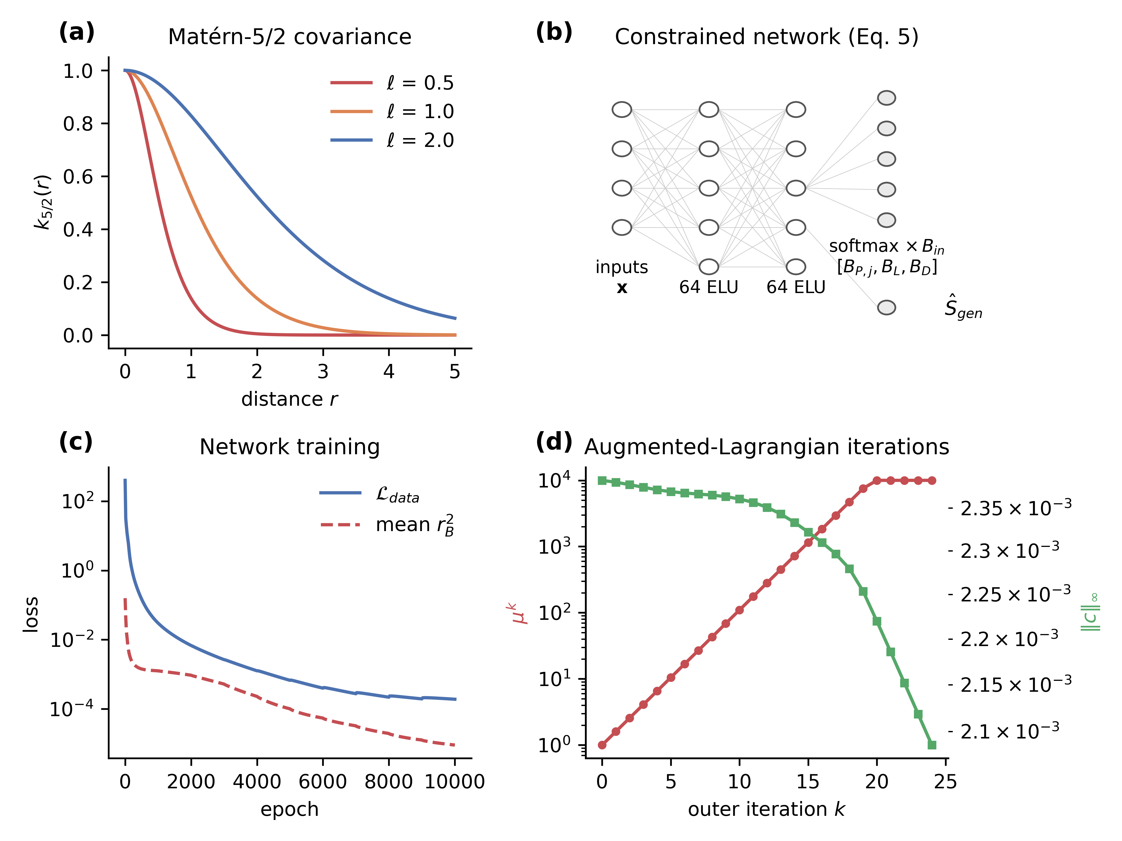
Figure 1. Surrogate models and training: (a) Matérn-5/2 kernel at three length scales; (b) constrained network with the output layer of Eq. (5); (c) data and physics losses during network training; (d) penalty parameter and constraint violation over augmented-Lagrangian iterations.

2.4 Exergy-balance validator
Each prediction is accepted only if $\left|r_{B}\right|≤ε$, ${\hat{B}}_{D}≥0$ and ${\hat{B}}_{P,j}≥0$; the tolerance is $ε={10}^{-2}$ and the last two conditions hold automatically for the constrained network. A rejected prediction is replaced by a reference-model evaluation at the same input, which is added to the training set, so the rejection rate and the fallback rate are one quantity. Retraining is triggered when the mean of $\left|r_{B}\right|$ over a sliding window exceeds $κε$, with $κ$ between 2 and 5.
The multiplicative output correction used in the earlier version of this framework has been removed. Scaling all co-product exergies by a common factor leaves the allocation factors of Eq. (3) unchanged, so it enforced closure numerically without altering the allocation or establishing validity.

2.5 Sampling strategy
Training inputs are drawn by Latin hypercube sampling (McKay et al., 1979); collocation inputs for Eq. (6) come from a Sobol’ sequence (Sobol’, 1967). The relative importance of input $p$ is scored as
$$γ_{p}=\left|\frac{∂λ_{k}}{∂x_{p}}\right|\frac{σ_{p}}{μ_{p}} \left(9\right)$$
where $λ_{k}$ is an allocation factor and $μ_{p}$, $σ_{p}$ are the mean and standard deviation of $x_{p}$, with derivatives estimated by finite differences at the nominal point. An adaptive alternative was also tested, in which batches are added where the GP predictive standard deviation is largest, with batch size proportional to that maximum (Figure 2c).
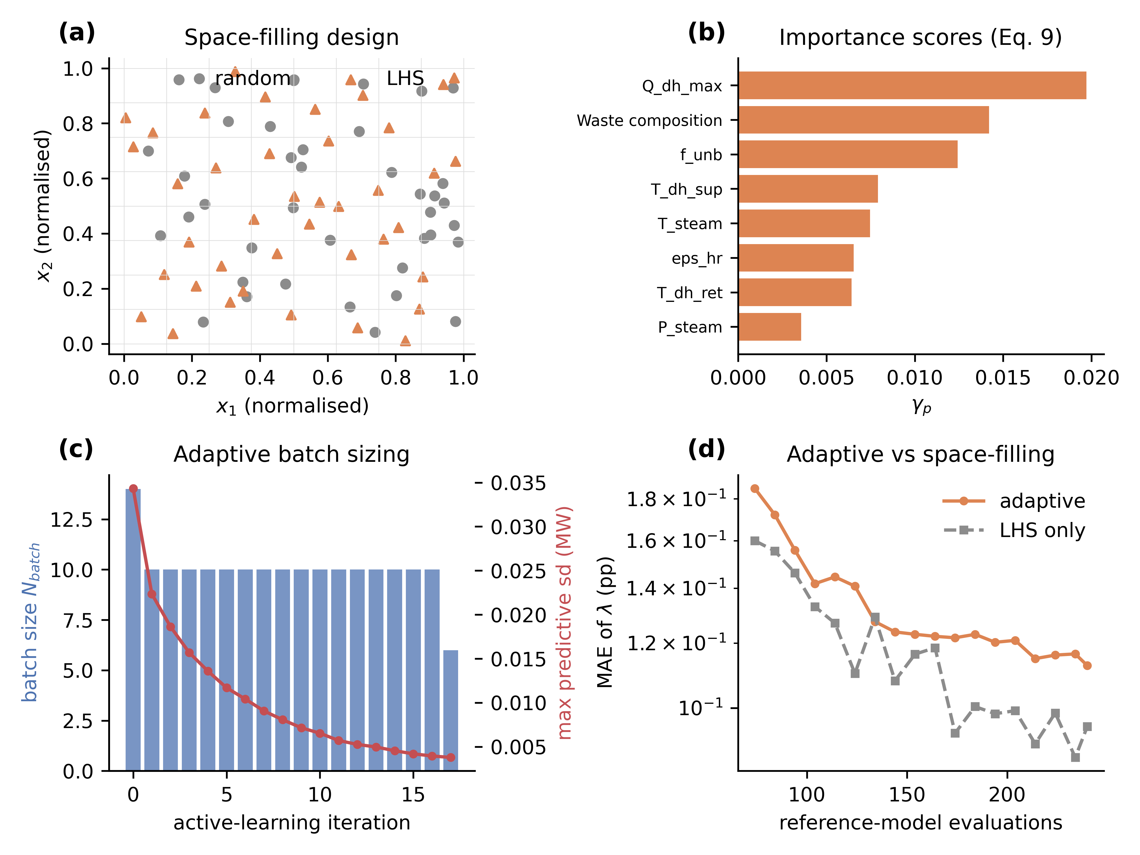
Figure 2. Sampling of the input space: (a) Latin hypercube versus random design; (b) importance scores of Eq. (9); (c) adaptive batch size and predictive uncertainty; (d) accuracy of adaptive against space-filling designs at equal budget.

2.6 Validation protocol
Five variants were compared on identical training, collocation and test sets: physics-informed GP (GP-PI), unconstrained GP (GP-plain), network with hard closure (NN-hard), network with the training penalty only (NN-soft), and unconstrained network (NN-plain). The whole procedure was repeated eight times with different random seeds, and accuracy is reported as the mean with a 95% confidence interval over repetitions. Errors are given in percentage points of the allocation factor. Marginal distributions of $λ_{j}$ from 10,000 surrogate predictions were compared with the 10,000-sample Monte Carlo analysis using the two-sample Kolmogorov–Smirnov test at the 5% level (Massey, 1951), and correlations with 95% bootstrap intervals from 2,000 resamples (Efron, 1979). Sobol’ indices were estimated with the Saltelli et al. (2010) design.

3 Case study: municipal waste-to-energy benchmark

3.1 Plant and exergy model
The case study is a reduced-order but complete reference model of a mass-burn WtE plant treating 500 t/day (5.79 kg/s) of municipal solid waste, with a steam cycle supplying electricity and district heat. It is a documented benchmark built from representative composition and operating data rather than measurements from a particular facility, and the full implementation is released so that every result can be reproduced. The boundary covers waste reception, grate combustion, boiler, steam turbine, district-heating heat exchangers and stack. The co-products are net electricity, district heat and bottom ash; the losses are stack gas, casing losses and rejected condenser heat.
The reference environment is $T_{0}=298.15$ K and $P_{0}=101.325$ kPa with standard chemical exergies from Szargut et al. (1988). The chemical exergy of each of the twelve waste categories is its lower heating value multiplied by a category-specific factor $β$ between 1.06 and 1.25 for combustible fractions and zero for glass and metals (Supplementary Table S2). The exergy of electricity equals the net electrical output; the exergy of district heat is $Q\left(1-T_{0}/T_{lm}\right)$ with $T_{lm}$ the logarithmic mean of supply and return temperatures (Bejan et al., 1996); the exergy of bottom ash comprises the chemical exergy of unburnt material and its physical exergy at the discharge temperature of 200 °C. Exergy destruction is computed component-wise as the irreversibility of combustion, boiler and power block, and entropy generation follows from the Gouy–Stodola relation, so Eq. (2) is not used to infer destruction by difference. The balance closes to within 3 × 10⁻¹⁶ of $B_{in}$ at every sampled point.
The benchmark was checked against published plant statistics. Its mixture heating value of 11.17 MJ/kg is close to the average net calorific value of 2.9 MWh/tonne (10.4 MJ/kg) used in the European R1 guidance, and its net electrical efficiency of 20.6% at 182 kt/year lies within the range reported for European plants, where large facilities remain below about 25% and smaller ones below 20% (Reimann, 2012). The benchmark is therefore representative of a mid-sized European combined-heat-and-power WtE plant, while remaining a constructed reference case rather than a specific facility.
At the nominal operating point, the fuel input is 64.6 MW and the input exergy 72.6 MW, of which 13.3 MW leaves as electricity, 3.85 MW as district heat and 0.90 MW with the ash, while 2.09 MW is lost and 52.5 MW destroyed, giving a net electrical efficiency of 20.6% and an exergy efficiency of 24.9%. Combustion accounts for 32.9 MW of the destruction, the boiler for 13.7 MW and the power block for 5.8 MW. The nominal allocation factors are 0.738 for electricity, 0.213 for heat and 0.050 for ash (Supplementary Tables S1 and S4).

3.2 Uncertain inputs
The model has 22 uncertain inputs. The mass fractions of the twelve waste categories follow a Dirichlet distribution with concentration 120 about the nominal composition. The remaining ten are the boiler heat-transfer effectiveness (truncated normal, mean 0.93, standard deviation 0.015), the unburnt fuel fraction (uniform, 0.005–0.020), live-steam temperature (400–450 °C) and pressure (40–60 bar), district-heating effectiveness (0.65–0.75), auxiliary power fraction (0.030–0.060), district-heating supply (85–105 °C) and return (45–60 °C) temperatures, stack temperature (130–160 °C) and district-heat demand limit (20–40 MW), all uniform. Dependence among the continuous inputs is imposed with a Gaussian copula, including a correlation of 0.60 between steam temperature and pressure and of −0.45 between boiler effectiveness and stack temperature (Supplementary Table S3). Over 10,000 samples the allocation factors are 0.747 ± 0.025 for electricity, 0.203 ± 0.022 for heat and 0.050 ± 0.016 for ash.

3.3 Implementation and computational cost
The reference model, the surrogates and the augmented-Lagrangian training are implemented in NumPy; GP hyperparameters are obtained by marginal-likelihood optimisation with scikit-learn (Pedregosa et al., 2011) on a separate 480-point design and then held fixed, so that all variants share identical kernels. All computations ran on a single CPU core. The reference model takes 0.0108 ms per sample, so the 10,000-sample Monte Carlo analysis takes 0.126 s, and hyperparameter fitting takes 53 s once. Training on 240 points takes 4.5 s for GP-PI, 0.03 s for GP-plain and 8.3–17.0 s for the networks; prediction takes 0.296 ms per sample for the GP and 0.0016 ms for the networks.

4 Results and discussion

4.1 Accuracy against unconstrained baselines
With 240 training points, the mean absolute error of the allocation factors over eight repetitions were 0.092 percentage points (95% CI 0.089–0.095) for GP-PI and 0.091 (0.088–0.094) for GP-plain, with maximum errors of 0.76 and 0.74 points and $R^{2}$ of 0.995 for the electricity factor. The physics penalty therefore did not improve GP accuracy: the training data already satisfy the balance, so the constraint adds little information. Among the networks, NN-soft and NN-plain were equivalent at 0.697 (0.651–0.743) and 0.698 (0.653–0.743) points, whereas NN-hard was about four times worse at 2.60 (2.31–2.89) points, with $R^{2}$ below zero for the electricity factor. This follows from the architecture rather than from optimisation: exergy destruction is about 72% of the input exergy, so distributing $B_{in}$ through a single softmax that includes the destruction channel makes the much smaller co-product exergies sensitive to relative error in that channel.
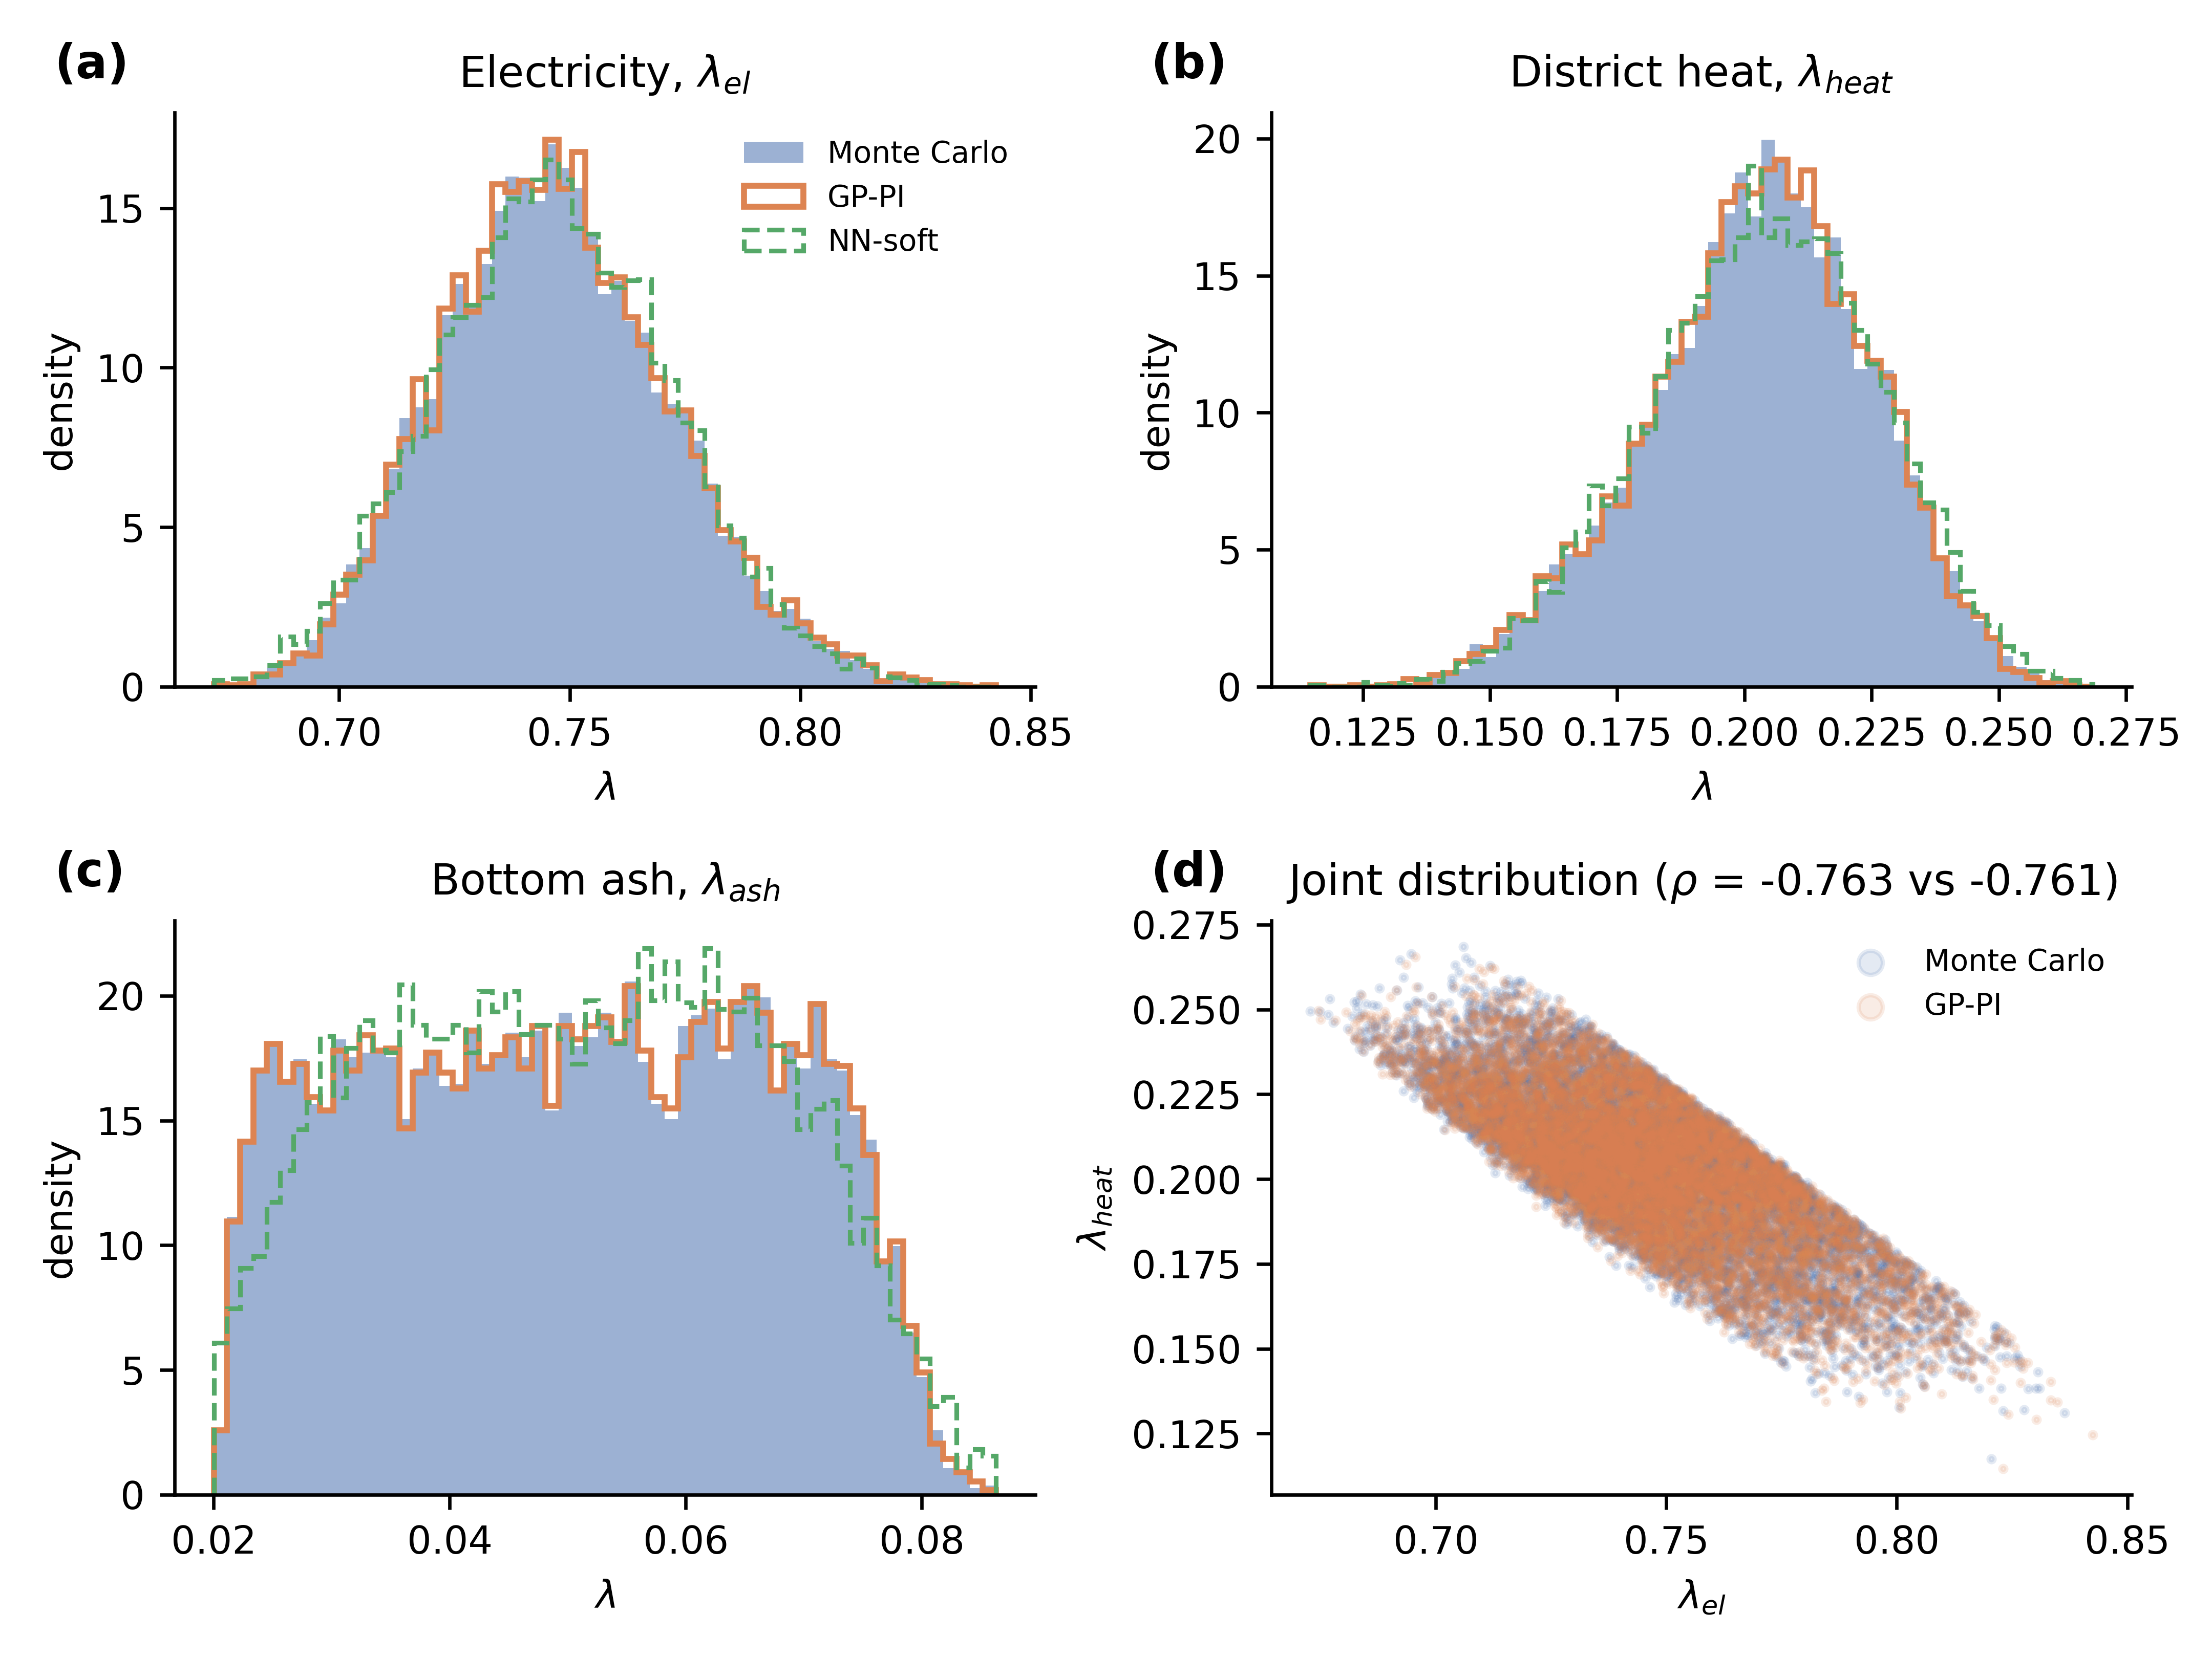
Figure 3. Allocation-factor distributions from the Monte Carlo analysis and the surrogates on the same 10,000 inputs: (a) electricity, (b) district heat, (c) bottom ash, (d) joint distribution of the electricity and heat factors.
Figure 3 compares the distributions. For both GP variants the Kolmogorov–Smirnov test never rejected equality with the Monte Carlo marginals, in any repetition or for any co-product (median p ≥ 0.96; mean statistic D ≤ 0.008). For NN-soft the test rejected equality in 25% of repetitions for electricity, 88% for heat and 75% for ash, and for NN-hard in every repetition (D ≈ 0.18–0.19 for electricity and heat). The claim that surrogate distributions are preserved is therefore supported for the GP but not for the networks at this training budget.
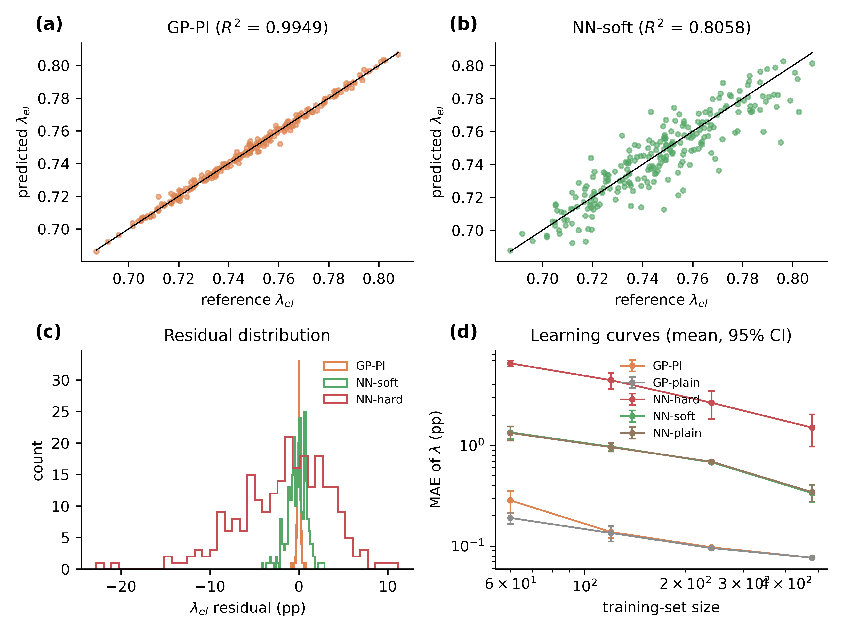
Figure 4. Accuracy on 240 held-out points: parity plots for (a) GP-PI and (b) NN-soft; (c) residual distributions; (d) learning curves with 95% confidence intervals over repetitions.
The learning curves in Figure 4(d) show the same ordering across budgets. Mean errors fall from 0.28 to 0.077 points for GP-PI and from 0.19 to 0.077 for GP-plain as the training set grows from 60 to 480 points, and from 1.34 to 0.34 points for NN-soft. The physics penalty was slightly detrimental for the GP at the smallest budget, where it competes with a weakly determined fit, and made no difference from 120 points upwards. Adaptive sampling by maximum predictive variance did not outperform Latin hypercube designs at equal budget (Figure 2d), reaching 0.11 rather than 0.09 points at 240 evaluations.

4.2 Sensitivity and correlation structure
Variance-based sensitivity analysis with 53,248 reference evaluations shows that the electricity allocation factor is governed by the district-heat demand limit (first-order index 0.33) and the unburnt fuel fraction (0.30), followed by the district-heating supply temperature (0.10) and the live-steam temperature (0.08), with waste composition contributing 0.06. The heat factor is dominated by the demand limit (0.45) and the supply and return temperatures (0.15 and 0.10), and the ash factor almost entirely by the unburnt fraction (0.99). Differences between total-order and first-order indices are below 0.04, so interactions are weak. This differs from the previous submission, which attributed the dominant role to waste composition and combustion efficiency. The allocation factors are strongly dependent: the electricity–heat correlation is −0.763 (95% CI −0.770 to −0.756), electricity–ash −0.506 (−0.520 to −0.493) and heat–ash −0.172 (−0.189 to −0.153). The GP surrogate reproduced the electricity–heat correlation as −0.761.
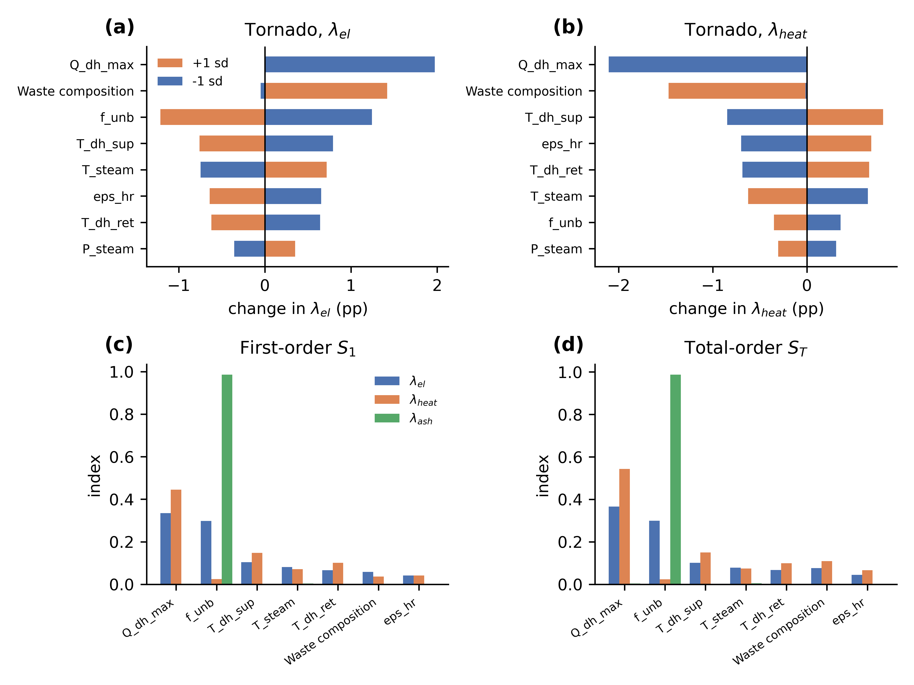
Figure 5. Sensitivity of the allocation factors: tornado diagrams for (a) electricity and (b) district heat; (c) first-order and (d) total-order Sobol’ indices.

4.3 Validator and reference-model fallback
Over the 10,000-sample analysis at $ε={10}^{-2}$, neither GP variant produced a single rejection and no prediction implied negative exergy destruction; the median residual was 2.6 × 10⁻⁴. The networks were rejected far more often: 51.6% for NN-plain, 37.2% for NN-soft and 47.3% for NN-hard. The penalty therefore reduced rejections by about a quarter relative to the unconstrained network at equal accuracy, which is the practical benefit of physics-informed training in this case study. Replacing rejected predictions with reference-model evaluations reduced the mean allocation error from 0.688 to 0.310 points for NN-plain, from 0.697 to 0.409 for NN-soft and from 3.15 to 1.61 for NN-hard, so the validator converts part of the surrogate error into additional reference-model calls. Residual distributions and the dependence of the rejection rate on $ε$ are shown in Figure 6.
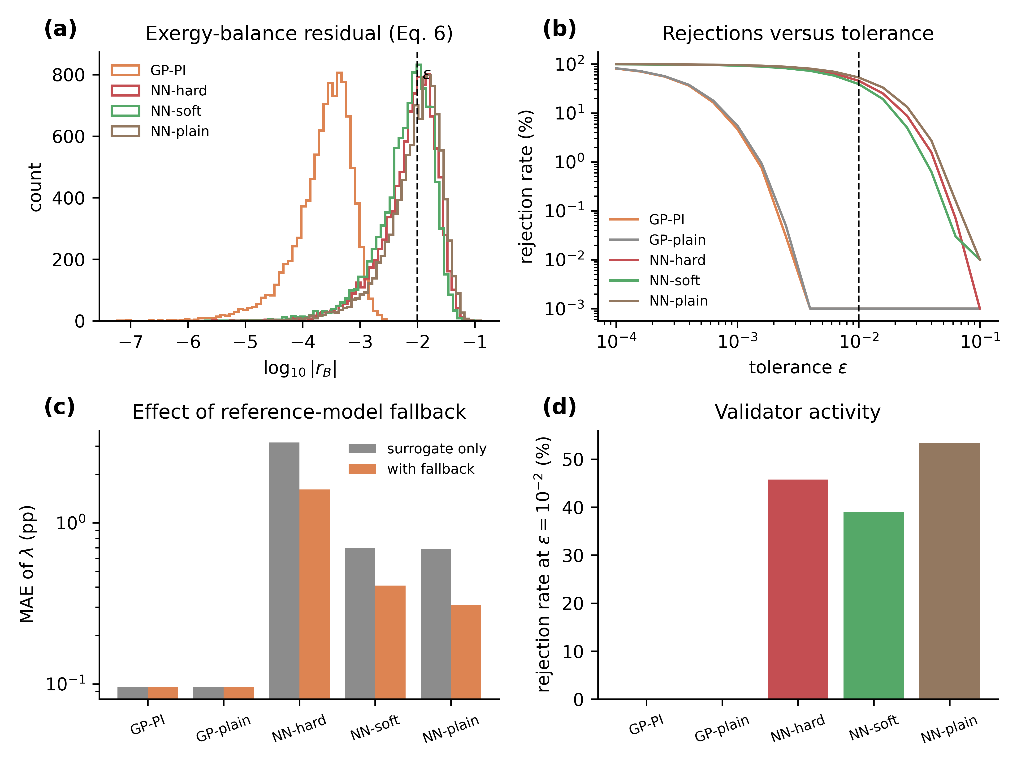
Figure 6. Validator behaviour: (a) distribution of the residual of Eq. (6); (b) rejection rate against tolerance; (c) effect of reference-model fallback on accuracy; (d) rejection rates at the working tolerance.

4.4 Computational cost
The Monte Carlo analysis required 10,000 reference evaluations. GP-PI required 440, comprising 240 training and 200 collocation inputs, with no fallback evaluations, a 22.7-fold reduction in reference-model calls; NN-soft required 4,348 including fallbacks, a 2.3-fold reduction. Wall-clock gain, however, depends on the cost of the reference model. In this benchmark that model costs 0.0108 ms per sample while GP prediction costs 0.296 ms, so the surrogate is slower than the model it replaces and the framework offers no wall-clock benefit here. Figure 7(c) projects the speed-up as a function of reference-evaluation cost using the measured training and prediction times: the GP pipeline breaks even at about 0.3 ms per reference evaluation and approaches its asymptotic 22.7-fold gain for models costing more than about 0.1 s per evaluation, which is the regime of detailed process simulations. Reporting the speed-up in this way, rather than as a single figure, makes the result transferable to other reference models.
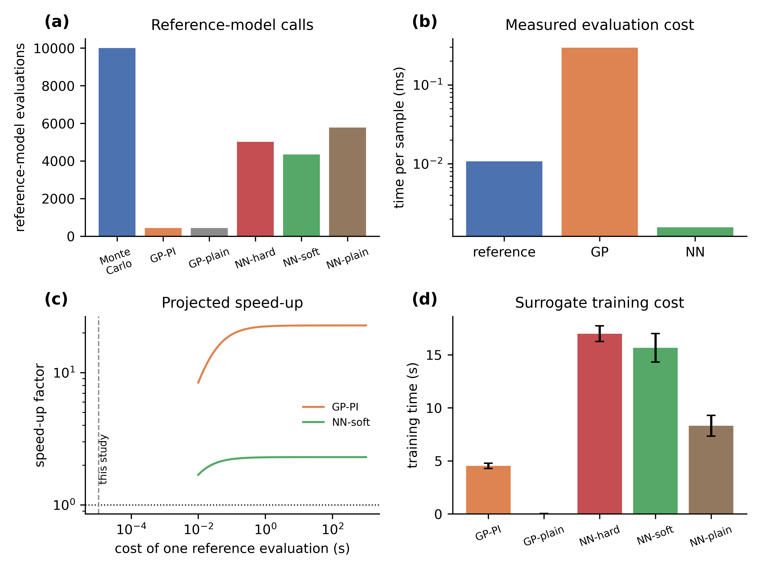
Figure 7. Computational cost: (a) reference-model evaluations required; (b) measured cost per sample; (c) projected speed-up against reference-model cost; (d) surrogate training times.

4.5 Practical guidance
Three recommendations follow from the comparison. Where the reference model is smooth and the training budget is modest, a Gaussian process is preferable: it met the balance at every one of 10,000 predictions without any penalty, so the constraint can be omitted and the validator retained as a guarantee. Where a network is required, the balance should enter as a training penalty rather than as a hard output constraint, since the penalty reduced rejections by a quarter at no accuracy cost while hard closure was counter-productive. Hard closure should be avoided whenever one term of the balance dominates, as exergy destruction does in combustion systems, because the co-product exergies then inherit the relative error of the dominant channel. In all cases the validator with reference-model fallback is worth retaining: it is inexpensive when the surrogate is accurate and it bounds the error when it is not.

4.6 Limitations
The benchmark is a reduced-order model of one plant with three co-products, and its smoothness favours the GP; rougher or higher-dimensional responses would narrow the gap to the networks. GP cost grows cubically with training-set size, so the 22.7-fold reduction in reference calls will not persist at much larger training budgets. Surrogates are valid only within the sampled input domain, and the stationarity assumption excludes dynamic LCA. Finally, the conclusion on hard closure applies to systems in which exergy destruction dominates the balance, which is typical of combustion plants but not of all processes.

5 Conclusions
Gaussian-process and neural-network surrogates were developed for exergy-based allocation under the exergy balance including destruction, with a validator replacing infeasible predictions by reference-model evaluations. On a documented waste-to-energy benchmark the Gaussian process reproduced the Monte Carlo allocation distributions with a mean error of 0.09 percentage points from 440 reference evaluations, a 22.7-fold reduction in model calls. Physics-informed training did not improve accuracy but reduced network validator rejections from 51.6% to 37.2%, and enforcing closure in the output layer degraded accuracy fourfold. Wall-clock benefit requires a reference model costing more than about 0.3 ms per evaluation.

Data availability
The reference model, the surrogate implementations and the scripts that generate every figure and reported number are provided as supplementary files (model.py, surrogates.py, runner.py, figures.py). Supplementary Tables S1–S6 document the nominal mass and energy balance, the reference environment and chemical-exergy data, the input distributions and correlation matrix, the nominal allocation calculation, the surrogate settings and the repeated-run statistics.

References
Bejan, A., Tsatsaronis, G., & Moran, M. J. (1995). Thermal design and optimization. John Wiley & Sons.
Bhering Trindade, A., Renó, M.L.G., Rúa Orozco, D.J., Martín Martínez Reyes, A., Vitoriano Julio, A.A. and Escobar Palacio, J.C. (2021) ‘Comparative analysis of different cost allocation methodologies in LCA for cogeneration systems’, Energy Conversion and Management, Vol. 241, p.114230.
Clevert, D-A., Unterthiner, T. and Hochreiter, S. (2016) ‘Fast and accurate deep network learning by exponential linear units (ELUs)’, in 4th International Conference on Learning Representations (ICLR 2016), San Juan, Puerto Rico.
Cornelissen, R.L. and Hirs, G.G. (2002) ‘The value of the exergetic life cycle assessment besides the LCA’, Energy Conversion and Management, Vol. 43, Nos. 9–12, pp.1417–1424.
Dai, T., Jordaan, S.M. and Wemhoff, A.P. (2022) ‘Gaussian process regression as a replicable, streamlined approach to inventory and uncertainty analysis in life cycle assessment’, Environmental Science & Technology, Vol. 56, No. 6, pp.3821–3829.
Efron, B. (1992). Bootstrap methods: another look at the jackknife. In Breakthroughs in statistics: Methodology and distribution (pp. 569-593). New York, NY: Springer New York.
Hestenes, M.R. (1969) ‘Multiplier and gradient methods’, Journal of Optimization Theory and Applications, Vol. 4, No. 5, pp.303–320.
Hung, M.L. and Ma, H.W. (2009) ‘Quantifying system uncertainty of life cycle assessment based on Monte Carlo simulation’, International Journal of Life Cycle Assessment, Vol. 14, No. 1, pp.19–27.
Kingma, D.P. and Ba, J. (2015) ‘Adam: a method for stochastic optimization’, in 3rd International Conference on Learning Representations (ICLR 2015), San Diego, CA, USA.
Massey, F.J. (1951) ‘The Kolmogorov–Smirnov test for goodness of fit’, Journal of the American Statistical Association, Vol. 46, No. 253, pp.68–78.
McKay, M.D., Beckman, R.J. and Conover, W.J. (1979) ‘A comparison of three methods for selecting values of input variables in the analysis of output from a computer code’, Technometrics, Vol. 21, No. 2, pp.239–245.
Pedregosa, F., Varoquaux, G., Gramfort, A., Michel, V., Thirion, B., Grisel, O., Blondel, M., Prettenhofer, P., Weiss, R., Dubourg, V., Vanderplas, J., Passos, A., Cournapeau, D., Brucher, M., Perrot, M. and Duchesnay, E. (2011) ‘Scikit-learn: machine learning in Python’, Journal of Machine Learning Research, Vol. 12, pp.2825–2830.
Peters, G.P. (2007) ‘Efficient algorithms for life cycle assessment, input-output analysis, and Monte-Carlo analysis’, International Journal of Life Cycle Assessment, Vol. 12, No. 6, pp.373–380.
Raissi, M., Perdikaris, P. and Karniadakis, G.E. (2019) ‘Physics-informed neural networks: a deep learning framework for solving forward and inverse problems involving nonlinear partial differential equations’, Journal of Computational Physics, Vol. 378, pp.686–707.
Rasmussen, C. E., & Williams, C. (2006). Gaussian processes for machine learning the mit press. Cambridge, MA, 32, 68.
Reimann, D. O. (2012). CEWEP energy report III. Scientific & Technical Advisor to CEWEP, Bamberg Dezember.
Rocco, M.V., Di Lucchio, A. and Colombo, E. (2017) ‘Exergy life cycle assessment of electricity production from waste-to-energy technology: a hybrid input-output approach’, Applied Energy, Vol. 194, pp.832–844.
Saltelli, A., Annoni, P., Azzini, I., Campolongo, F., Ratto, M. and Tarantola, S. (2010) ‘Variance based sensitivity analysis of model output. Design and estimator for the total sensitivity index’, Computer Physics Communications, Vol. 181, No. 2, pp.259–270.
Sobol’, I.M. (1967) ‘On the distribution of points in a cube and the approximate evaluation of integrals’, USSR Computational Mathematics and Mathematical Physics, Vol. 7, No. 4, pp.86–112.
Szargut, J., Morris, D. R., & Steward, F. R. (1988). Exergy analysis of thermal, chemical, and metallurgical processes. (No Title).

Supplementary Material
All values are outputs of the released reference implementation (model.py, surrogates.py, runner.py, figures.py) and can be reproduced exactly.

Table S1. Nominal mass and energy balance
Quantity | Value | Note
Waste throughput | 5.79 kg/s | 500 t/day
Mixture lower heating value | 11.17 MJ/kg | mass-weighted over 12 categories
Fuel energy input | 64.64 MW | LHV basis
Flue gas mass flow | 46.5 kg/s | 0.63 kg per MJ of fuel
Furnace exit temperature | 1492 K | energy balance on flue gas
Unburnt energy to ash | 0.81 MW | unburnt fraction x fuel energy
Heat to steam cycle | 53.40 MW | boiler effectiveness on available heat
Stack loss | 6.42 MW | sensible heat at stack temperature
Casing / radiation loss | 4.02 MW
Gross electrical power | 13.96 MW | exergetic efficiency of power block
District heat delivered | 27.60 MW | limited by demand
Bottom ash | 1.16 kg/s | 20% of input mass, discharged at 200 °C
Net electrical efficiency | 20.6% | net power / fuel energy
Exergy efficiency | 24.9% | co-product exergy / input exergy

Table S2. Waste categories, reference environment and chemical exergy
Reference environment: T0 = 298.15 K, P0 = 101.325 kPa; standard chemical exergies after Szargut et al. (1988).
Category | LHV (MJ/kg) | beta = b_ch/LHV | Nominal mass fraction
Paper and cardboard | 13.5 | 1.13 | 0.220
Plastics | 32.0 | 1.06 | 0.120
Food waste | 4.5 | 1.20 | 0.240
Garden waste | 6.0 | 1.15 | 0.080
Wood | 15.0 | 1.13 | 0.050
Textiles | 17.0 | 1.12 | 0.050
Rubber and leather | 20.0 | 1.08 | 0.020
Nappies | 8.0 | 1.17 | 0.040
Fines and inerts | 2.0 | 1.25 | 0.060
Glass | 0.0 | 0.00 | 0.050
Metals | 0.0 | 0.00 | 0.040
Other combustibles | 12.0 | 1.14 | 0.030
Bottom ash: chemical exergy of unburnt material taken as 1.06 x unburnt energy; physical exergy from cp = 0.90 kJ/kg K at 473.15 K. District heat exergy: Q (1 - T0/T_{lm}) with T_{lm} the logarithmic mean of supply and return temperatures.

Table S3. Uncertain inputs and dependence structure
Input | Distribution | Parameters
Waste mass fractions (12) | Dirichlet | concentration 120 x nominal composition (Table S2)
Boiler heat-transfer effectiveness | normal | truncated normal, mean 0.930, sd 0.015, limits 0.88–0.97
Unburnt fuel fraction | uniform | uniform, 0.005 to 0.02
Live-steam temperature (°C) | uniform | uniform, 400 to 450
Live-steam pressure (bar) | uniform | uniform, 40 to 60
District-heating effectiveness | uniform | uniform, 0.65 to 0.75
Auxiliary power fraction | uniform | uniform, 0.03 to 0.06
District-heat supply temperature (°C) | uniform | uniform, 85 to 105
District-heat return temperature (°C) | uniform | uniform, 45 to 60
Stack temperature (°C) | uniform | uniform, 130 to 160
District-heat demand limit (MW) | uniform | uniform, 20 to 40

Gaussian copula correlations among the continuous inputs (all other pairs independent):
Pair | Correlation
Boiler heat-transfer effectiveness / Unburnt fuel fraction | -0.30
Boiler heat-transfer effectiveness / Stack temperature (°C) | -0.45
Live-steam temperature (°C) / Live-steam pressure (bar) | 0.60
District-heating effectiveness / District-heat supply temperature (°C) | 0.35

Table S4. Exergy balance and allocation at the nominal point
Term | Exergy rate (MW) | Share of B_{in} (%) | Allocation factor
Waste chemical exergy (input) | 71.995 | 99.13 | –
Auxiliary electricity (input) | 0.628 | 0.87 | –
Net electricity (co-product) | 13.336 | 18.36 | 0.738
District heat (co-product) | 3.849 | 5.30 | 0.213
Bottom ash (co-product) | 0.895 | 1.23 | 0.050
Stack gas (loss) | 1.024 | 1.41 | –
Casing loss | 0.495 | 0.68 | –
Rejected condenser heat (loss) | 0.567 | 0.78 | –
Destruction, combustion | 32.942 | 45.36 | –
Destruction, boiler | 13.747 | 18.93 | –
Destruction, power block | 5.769 | 7.94 | –
Total input B_{in} | 72.624 | 100.00 | –
Entropy generation S_{gen} | 175.9 kW/K | – | –
Balance residual, Eq. (2) | 9.8e-17 | – | –

Table S5. Surrogate settings
Setting | Value
Training / test / collocation points | 240 / 240 / 200
Monte Carlo sample size | 10000
Repetitions (main / learning curve) | 8 / 3
Validator tolerance | 1e-⁰²
GP kernel | Matérn-5/2 with automatic relevance determination
GP hyperparameters | marginal likelihood on a separate 480-point design, then fixed
GP jitter | 1e-6
Augmented Lagrangian | mu0 = 1, rho = 1.6, mu_{max} = 1e² (network) / 1e⁴ (GP), 25 outer iterations (GP)
Network architecture | 2 hidden layers x 64 ELU units, two output heads
Network optimiser | Adam, learning rate 3e⁻³ with cosine decay
Network epochs (main / learning curve) | 10000 / 5000
Hardware | single CPU core

Table S6. Repeated-run statistics (mean and 95% confidence interval over 8 repetitions)
Variant | MAE (pp) | Max error (pp) | R2 (electricity) | Median abs(r_{B}) | Rejections (%) | Training time (s)
GP-PI | 0.092 (0.089–0.095) | 0.76 | 0.9949 | 2.6e-04 | 0.00 | 4.5
GP-plain | 0.091 (0.088–0.094) | 0.74 | 0.9950 | 2.7e-04 | 0.00 | 0.0
NN-hard | 2.601 (2.308–2.894) | 16.83 | -2.5926 | 9.4e-03 | 47.34 | 17.0
NN-soft | 0.697 (0.651–0.743) | 4.18 | 0.7993 | 7.4e-03 | 37.19 | 15.7
NN-plain | 0.698 (0.653–0.743) | 4.34 | 0.8020 | 1.0e-02 | 51.56 | 8.3

Kolmogorov–Smirnov comparison against the 10,000-sample Monte Carlo marginals (fraction of repetitions in which equality is rejected at the 5% level):
Variant | Electricity | District heat | Bottom ash | Mean statistic D (electricity)
GP-PI | 0% | 0% | 0% | 0.0065
GP-plain | 0% | 0% | 0% | 0.0052
NN-hard | 100% | 100% | 100% | 0.1828
NN-soft | 25% | 88% | 75% | 0.0181
NN-plain | 38% | 100% | 62% | 0.0185
Learning curves, mean MAE in percentage points:
Variant | 60 points | 120 points | 240 points | 480 points
GP-PI | 0.284 | 0.138 | 0.097 | 0.077
GP-plain | 0.190 | 0.135 | 0.096 | 0.077
NN-hard | 6.511 | 4.432 | 2.644 | 1.500
NN-soft | 1.343 | 0.971 | 0.680 | 0.335
NN-plain | 1.327 | 0.958 | 0.689 | 0.343
Validator fallback over the 10,000-sample analysis:
Variant | Rejections (%) | MAE before (pp) | MAE after fallback (pp) | Reference-model calls
GP-PI | 0.00 | 0.096 | 0.096 | 440
GP-plain | 0.00 | 0.096 | 0.096 | 440
NN-hard | 45.75 | 3.152 | 1.612 | 5015
NN-soft | 39.08 | 0.697 | 0.409 | 4348
NN-plain | 53.34 | 0.688 | 0.310 | 5774

S7. Code
model.py (reference plant and sampler), surrogates.py (GP and network surrogates with augmented-Lagrangian training), runner.py (experiment stages), figures.py (all figures). Monte Carlo: 10,000 samples; Sobol analysis: 53,248 reference evaluations.

